# Abstract:

A valuable tool for almost real-time marketing, public opinion, and customer knowledge mining in conjunction with the brands Twitter and other microblogging services. The research on automated sentiment analysis focuses therefore upon the compilation and analysis of natural language content created by users. The most successful approach is mastered machine learning, which includes data cleaning and transformation, the generation of features and the choice of model and the selection of parameters. Documents have been extensively reviewed in recent years and it is understood that relatively simple techniques such as textual conversion and Naive bayes models can produce acceptable results and good tuning can be difficult, producing relatively limited results (75 percent to 85 percent F1 scores for the average dataset). But even with a mid-sized dataset, many percentage levels of success can mean thousands of better classified materials, meaning thousands of lost or unhappy customers in any business sector. In the existing data sets of 6 US airlines we have tweets and we have to predict whether the tweets are positive, negative or neutral. It is a standard supervised job, where a problem statement is given to us and categorized into a predetermined category. Experiments show Naive Bayes, logistic regression, decision tree classification, random forest, KNN classifiers with domain specific terminals, and check whether the data has not been imbalanced or whether the groups are not binary. To improve the predictive efficiency, filtering stopwords is crucial; and the experiment shows that a collection of stopwords should be domain specific. The inference is that in sentiment analysis, there is no optimal way to model training and stopword collection. This paper therefore suggests that a comparison framework can be used to fine tune prediction trends for a given problem: a comparison framework can compare various training settings on the same data set so that the best trained models for a given real-life problem can be identified.

Table of Contents

Abstract: 1

1. Introduction 2

1.1 The aim of this work 3

2. Previous work in the field 4

3. Theoretical background: 9

4. Technical Implementation 21

4.1. Supervised Machine learning 21

4.2.1 Bag of words methods 21

4.2.3. TF-IDF weighting 22

4.2.4. Data gathering 23

4.2.5 Exploratory Data analysis 24

4.2.6. Word frequency in the dataset 29

4.2.7 POS distribution in classes 32

4.31. Comparison of the predefined classes 32

4.3.2 Building the right training dataset 33

4.4 Pre-processing 34

4.4.1. String Normalization 34

4.4.2. Tokenization 35

4.4.3. Stopwords 35

4.4.4. Stemming / Lemmatization 36

4.4.5. N-gram converting 36

4.4.6. Synonyms 37

4.7.7. Part of Speech tagging 37

5. Model Building 37

5.1. Classifiers 38

5.2. Pre-processing datasets 39

5.3. Comparison matrices 39

5.4.1 Logistic regression: 44

5.4.2 Multinomial Naive bayes: 44

5.4.3 Decision tree algorithm: 45

5.4.4.Random Forest: 45

5.4.5 K Nearest neighbour classifier: 46

6. Result analysis: 47

7.Conclusion and Discussions: 48

References 50

# 1. Introduction

Text classification is associated with the study of emotions in the sense of natural language processing. Simply placed, nostalgic analysis is an attempt to understand a "theme's" context. A product analysis, for example, should be evaluated such that an automated device may classify the favorable, bad, or neutral value of the review. Emotions are a multidimensional framework, in sophisticated classification schemes, where any element has a meaning (as indignation, pleasure, and interest), rather than a class list or scale (as positive, bad, or neutral) (Snyder and Barzilay, 2007, (pp. 300-307)). Sentiment analysis is not only a grouping problem: it often involves identifying subjectivity, polarity, and associations between individuals and entities in natural language texts. The last point to consider (the subject/object relationship) is often related to identification. Outside of vocabulary, the most difficult issues for textual language functionality are mainly automated sentimental research. Negotiations, certain orders, modal verbs, and sarcasms, for example, all alter the situation.

In the field of feeling psychology, this work reflects on the classification of individuals. It is a broader field to classify natural language documents as a concern, in addition to feeling research. Simply placed, automatically applying labels (one or more) and evaluating content can be represented. Using journal articles with tags like 'economy,' 'policy,' or 'culture,' an e-mail filtering engine may identify emails as spam or 'relevant.' This dilemma is equivalent to categorizing a product review as "fair" or "poor." There are several ways to classifying a document's emotion. A simple binary (positive) system, a three-class (positive neutral) or one-to-ten system, or a multi-dimensional system are both instances of these. A content may be classified using a variety of methods. Although there are many classification algorithms usable, not all of them can be used with any classification scheme. When choosing a class structure, it's common to recommend setting limitations on the right classification selection. Technology for sentiment analysis has a broad range of applications, and new ones will be developed in the future. All of the following fields are currently open:

Marketing and identity management for the brand (the dataset of the current work is a typical example of this). The standard data collection technique is an automated method of keyword monitoring on sensitive networks, with the obtained data being evaluated utilizing pre-trained ranking systems. The methodology assists in the identification of weak points in order to improve brand reputation.Management and forecasting in public relations. Early negative facebook posts can be accommodated by digital systems and brand detractors. Similar to the prior example, advanced technologies would assist in the discovery of important individual communications such that the organization will effectively communicate with them.

Polling on digital policies. These emotion testing apps will dynamically review vast volumes of messages, and the results of a public article can be shown.Stock predictions rely on emotion. Any attempt is made to establish bourses (or other goods) for media and social media research. In this region, pace is important, and model retraining will be needed on a regular basis.Consumer care — the built-in customer priority notes will assist customer service in addressing their issues at the outset. For user and CRM applications, automatic text processing features have been included.

The emphasis of this research is on the most basic types of natural-language documents: brief "tweets." Twitter was created in 2006 and is the most popular microblogging website. Since the findings of emotion analysis are very brief and arbitrary, users post long messages of 140 characters. This makes it an excellent instrument for analyzing emotions; many studies depend on Twitter data. Wikipedia reports that 37% of the document is conversational, while 40% is "pointless babble" (Wikipedia, 'Twitter,' 2016-05-25). The subjective touch term requires this figure.

The internet has a huge array of knowledge on almost every topic. Individuals have seen the internet as a valuable resource that provides access to a diverse range of viewpoints and perspectives. People's opinions have a huge impact on others' views, attitudes, and purchasing choices. Today's knowledge exchange has evolved into an online-based aggregation of memories, observations, and perspectives. Companies will get a clearer understanding of what consumers are thinking about a product, subject, or other individual thanks to the rapid growth of online data . Twitter Sentiment Analysis has been more common in recent years for automated customer loyalty analysis of online services. For airline firms, customer input on their offerings is extremely important.

In this article, the Twitter airline dataset is examined, and the most frequent issues that arise during services are expected, as well as the position of the predicted tweets. Then, multiple emotion classification algorithms are evaluated and contrasted, including LogisticRegression, KNeighbors, SVC, DecisionTree, RandomForest, AdaBoost, and GaussianNB. Based on a reasonable consistency in the test data, the best feel classification algorithms have been selected for airline service companies. Related study is discussed in the following section on sentiment analysis and machine learning classification. The proposed method is then defined, as well as classification approaches. The findings of different sentiment classification algorithms evaluated on airline services datasets are described in the experiment section. Finally, the best sentiment analysis algorithm for airline services is introduced, along with some potential research directions.

# 1.1 The aim of this work

Twitter data mining is a relatively well-known area in natural language analysis and emotion perception, with many industrial uses. Machine learning algorithms that produce results using very easy approaches and can be used for testing problems and even real-life construction environments seem to be ideal for Twitter info. Since these technologies provide organisations with useful knowledge, it is critical that they are implemented properly and effectively.

The volume of knowledge gathered from microblogging platforms like Twitter has skyrocketed. Because of its significance, even a small improvement in the productivity of applications would yield significant value thanks to sentiment-based analysis. As a result, diverse industry applications and special areas necessitate changing the model. As a result, the alteration of this model work is contrasted. Proposals are used for the data collection of Airlines in this work after evaluating previous work on the subject and suggesting more promising alternatives (which is described in The Dataset section). A second dataset is used to ensure that not just one but still sufficiently broad data sets are gathered. The work is given a comparative context that explains the implementation and optimization of models. Has the study query, "How do I automatically, modularly, and easily select features in order to evaluate various models in Twitter analysis?" been asked in this research?

# 2. Previous work in the field

The findings have been closely examined because Twitter is a testing medium that is relatively available. The first Twitter papers were published in 2009 as a foundation for sensory perception. 2009, to be precise. 2009, to be precise. Twitter has data collection tools that is open to the public API (however, as the company also sees the value of the data, the public API gets more and more restrictive). However, data collections are now open for emotional analysis by the general public. The phenomenon below has been used in a number of nostalgic analytical papers, as well as on Twitter. The authors provide a broad overview of the topic as well as their goals. The research aims to find attributes that can boost grading by focusing on brand review. Microblogging platforms, according to experts, are a rich data base for evaluating the "product characteristics map" of emotions and opinion mining. Writers looking for a 'automatic building isolation instrument from worse assessments' in the Annual World Wide Website Meeting (pp. 519-528) (Twitter in Sentiment Analysis & Perception Mining: Pak and Paroubek: 2010 in LREc, vol. 10, no. 2010), pp.1320-1326) (Dave, Lawrence, Pennock, 2003).

The dataset divides the writers into groups. Some people use randomly generated data sets, and others use a variety of methods to create training data sets. The primary concerns are "critical branding accuracy" and "preventive labelling." Some poets, such as Barbosa and Junlan, are scavenging for facts (2010, twitter Sensitive Feeling Recognition based on biassed and noisy data). The issue is discussed under 'Compare the classes that have been described.' Posters at the 23rd International Conference on Computer Linguistics (pp. 36-44): To set a date for preparation, some people use a traditional method of learning (Go, Alec, and others, 2009; Stanford, 1(12) page 2009; CS224N Project Report). (2009, Go, Alec, and others.) in the year 2009 Pang, Lee, and Vaithyanathan 2002. ACL-02 conference on the scientific techniques of natural language processing Volume 10 (pages 79-86)). All of these are founded on multitude-based knowledge bases or crowd-oriented solutions. The method is as follows: The method is as follows: Standard data sets such as Stanford Twitter Sentiment Gold, Twitter Data Sets Sentiment Strength (Saif et al, 2003), and other data sets will be used for monitoring result analysis purposes.

The work is mostly concerned with the mechanical engineering method in general. This involves the use of machine learning algorithms to preprocess results (discussed in the pre-processing section). The above-mentioned technologies can be classified as follows: (In the pre-processing segment, each move is explained in detail.)

Analysis perspective and semanthropic product reviews (Dave, Kushal, and Pennock, 2003). Mining Peanut's photo gallery N-gram migration is discussed in detail in the 12th World Wide Web Conference (pages 519-528). 'The simplest attribute for Twitter feel research is the word n-gram functions.' [Access to IEEE, 5, pp.2870-2879, Jianqiang et al., 2017]. On Twitter, you can read the IEEE article. • POS transmission There is a summary of the optimum n-gram dimension, which most likely claims that this configuration is dependent on the data set and domain (part of the talk). The viability of using PS identifiers was shown by [these] methods. Unnoticed text grouping with both the subjective and factual sentences (Wiebe and Riloff, 2005). International conventions on smart text analysis and computer linguistics (Barbosa and Junlan, 2010) and Twitter sustainability of distorted and noisy proof (pp. 486-497). The 23rd International Computational Linguistics Conference will be held in the following locations: (Pages 36–44) posters

• Recognizing textual patterns (POS groups, syntactic trees..)

Semanticized and syntactic approaches are used. 'Semantic contexts,"semantic expressions,' and'sensory perception methods,' for example, are often used in linguistic science (Twitter, Saii, Fernandez, and Alani Semantic Contextual Analysis, 2016. Processing and Information Management (52(1), pp.5-19)). Since Ses approaches to sentiment analysis on Twitter are so unique, the focus of such works is often on personal execution.

The trial is underway. The functions are useful, according to the authors, and can help with results estimation. In the appraisal portion, a baseline score is always given, and the final score almost always exceeds it. A simple ranking, an uncertainty matrix, or a reminder value, for example, may be used to measure the piece (Jianqiang and Xiaolin, 2017,Comparison research on text pre-processing methods on twitter sentiment analysis. IEEE Access, 5, pp.2870-2879).

Though machine learning is the most innovative technology in the industry, the majority of papers concentrate on the functionality generation aspect. Many papers explain algorithms that are used and measure their effect (Dave, Kushal, & Pennock 2003, Mining the Peanut Gallery: Extracting opinions and classifying product ratings in a semantic way). The World Wide Web Conference will be held for the 12th time (p. 519-528). (Jianqiang and Xiaolin, 2017, IEEE Access, 5, p.2870-2879; Jianqiang and Xiaolin, 2017, Pre-processing textual analysis reference study). However, the algorithms in most documents aren't really detailed (parameters, implementations, etc..).

Twitter data is extensively investigated, as Twitter is an open source of useful information. The early papers on Twitter data sentiment analysis were published around 2009. Twitter provides public APIs with different data collection capabilities (but the public API is also becoming more and more limited because it also sees value). However, for sentiment analysis, there are a wide number of publicly accessible datasets. In documents on sentiment analysis, in particular about Twitter data, the following is a popular pattern.

Authors identify the field of issue and the study goal. The most popular subject is the review of the product and the research aims to recognize features that can enhance their classification. A number of authors concentrate on 'generating a list of product attributes' so that 'microblogging websites are rich data sources for the study of opinion. 'Authors seeking 'automatic methods of separating positive from negative feedback' (Dave, Lawrence and Pennock, 2003), (Pak and Paroubek, (2010).). Authors identify their dataset. Some use datasets that are automatically collected and attempt to build training datasets by using various techniques. It is the dataset segment where several writers highlight the problematic nature of Twitter data collection, some key issues are 'labeling consistency.'

The problem is discussed in the "Comparison of Predefined Classes Section" section of these works (Barbosa and Junlan, 2010). Some people use unexpected training methods to develop a training data collection or to use twitter functionality using remote monitoring, which consists of tweets for our training data. Using emoticons (Go, Alec and al., 2009). Such others have existing datasets, such as IMDB (Pange, Lee & Vaithyanathan 2002), which are compiled by others or crowdsourced solutions. There are available 'normal' datasets used for monitoring outcomes, such as the Sentiment Intensity Twitter Dataset (Saif et al, 2003) and Stanford Twitter Gold Sentiment and others. The key task typically is to explain the process of feature engineering. This includes the techniques of preprocessing which effectively transform the text into data which is processed by algorithms of machine learning. The techniques can be categorized into the next large categories.

§ Linguistic and replacement methods (Dave, Kushal and Pennock, 2003) To transform N-gram. 'The simplest feature for Twitter sentiment analysis is Word N-grams functions' (Jianqiang et al, 2017). There's a variety Opinions on the ideal n-gram dimensions; this thesis argues that Possibly the data set and the domain are used for the environment.

* Conversion to POS (Speech Part). '[These] methods have shown that POS tags are accurate. Intuition is that such POS tags are strong indicators of feelings (Wiebe and Riloff, 2005).
* Recognition of text patterns (POS groups, syntactic trees..) The approaches focused on semantics and syntax. Those strategies are traditionally focused on language studies such as 'Contextual semantic approaches', 'Conceptual semantic approaches' and 'Entity-Level Sentiment Analysis Approaches' (Saif, Francis and Alani, 2016). The main emphasis of these works is the personalized implementation. In the experiment, the authors show that the features proposed work effectively and can produce an improved prediction on the dataset. A base score is always provided in the assessment section, and almost always the outcome exceeds the base score. The assessment may be a simple score, uncertainty matrix, F1 score, or other metrics like accuracy and reminder (Jianqiang and Xiaolin, 2017). Machine learning techniques are the state of the art in the area, but most of the papers concentrate on the function output portion. Most papers identify the algorithms used, and compare the results between different algorithms (Dave, Kushal and Pennock, 2003), (Jianqiang and Xiaolin, 2017). But most reviews do not detail the algorithms (parameters, Deployments, etc..).

**On twitter data:**

A sensing research was performed in different phases of granularity as a natural language processing task. The importance at the text level is based on the sentencing concept (Pang & Lee, 2004; Turney 2002; Hu & Liu; Kim & Hovy, 2004; and thereafter). Agarwal et al. 2005; The choices internship, 2004; Wilson et al. 2005; (1995). Sensitivity of microblog Twitter is a consumer enterprise Real time and "everything" vision create new and diverse problems. This is the kind of thing, both of them. Conclusions of recent and early feelings Twitter data (2009) Go and al (Bermingham). Parubek & Smeaton & Pak (2010). Go and al. Go et al (2009) Learn how to gather feelings from a distance. Emoticons like ":" and ":-) are used in tweets which end in ":]" and ":-). "Generating Naive Bayes, MaxEnt and SVM, a number of SVM models will be showcased. Regarding the functional area, Enter Unigram, Bigram Connects Parts of speech features (POS). You realise that the unigram is bigger than any model. In specific, Bigrams and POS do not help. Data selection from Pak and Parubek (2010) Model of remote study is related. But: you group different tasks subjective vs objective. Tweets that end with emoticons is collected in the same way as subjective data Ok, oh, go, etc... (2009). They struggle with impartial outcomes The York Times, etc., is a popular Twitter newspaper. "The Post Office in Washington." "Instead of the results presented by Go et al, you report that POS and bigrams all support it (2009). However, all of them are mostly based on ngram models. The data used for advice and search queries also collect the assessments and are also available It's part of that. We've got features, though. A huge benefit from a baseline Unigram. A new approach to data representation and major modifications to Unigram styles are being tested. This article also helps to identify the data results that we publish manually. It has not been established any prejudices. Trade Data Mother is a random tweet archive of the data gathered for particular queries. Discrepancies By using our manually labelled scripts, we can run cross-validation tests and verify updates. In both folds classifier success. Another major effort to identify Twitter sentiment is Barbosa and Feng (2010). Three websites are used for predicting polarity Noisy model teaching stickers and 1000 manual use Tune tweets labelled and another 1000 manually labelled tweets for testing. They do, though. Don't mention the set of their research findings. It is you. Offer to use the features of tweet syntax Hashtags, retweets, links, punches and rhetoric Features such as polarity of previous term and POS word. We extend your business approach with the use of real polarity POS combination of preceding polarity. Our results are obvious features that enhance our performance Functions historically together have been the most frequent classificators. The polarity in terms of their pieces of speech. The Thing Help but insignificant Twitter syntax features. Gamon Sensation Review (2004) Global Support Services survey feedback info. One of their works is an interpretation of the role of Linguistic characteristics such as POS identifiers. You're doing it. Full rundown and feature set Prove abstract properties of language analysis Contributes to the precision of the classification. In this paper We do thorough study of features and demonstrate that A hard baseline unigram is performed by using only 100 abstract linguistic elements.

The tweets of three aviation companies such as Malaya Airlines, Jet Blue Airlines and Southeast Airlines were also analysed by Sreenivasan et al. and tweeted to research communicativity with passenger airline services(Chei Sian Lee, Dion Hoe-Lian Goh,pp. 21-42, 2012). Breen and others clarify classifying tweets by the addition of nostalgic lexicons and propose to retrieve tweets with queries including airline names from the Twitter API. This paper does not include data training or analysis procedures. Therefore this technique was used and validated for our work for pre-label results. The test results have been deceptive, since opinions are highly dominant (Jeffrey Oliver Breen. 2012, pp. 133) . Adeborna et al took a Bayesian Naive emotion detection approach compared with SVM and Entropy. The study results were 86.4 percent precise in a subjectivity classification and revealed some problems which explain the meaning of the feeling. In this study the author used only unigrams in the algorithm of Naive Bayes as classifications of feelings which can lead to problems because phrases and terms of negation modify the feeling of such vocabulary in sentences(Proceedings of PACIS 2014, p.363). My thesis compares seven ratings and increases the accuracy of random forest ratings. There has been discussion on the relationship between the sentiment classification and the field of airline service. Editor Baker collected data from the Department of Transportation Air Travel Consumer Report on metrics such as the proportion of time-booking departures, travellers' refuses, baggage malfunctioning and airline service-like complaints(David Mc. A Baker,Vol. 2, No. 1, 2013, pp. 67-77).

In his analysis of tweets, Mr. Sleenivasan et al. is responsible for three airline companies such as Malaysia Airlines, Jet Blue Airlines or Southwest Airlines. (Chei Sian Lee, Dion Hoe-Lian,46.1, pp. 21-42, 2012). Breen et al shows the classification of tweet feelings by the use of nostalgic lexicons and proposes that tweets with questions like airline names may be accessed through the Twitter API in real-time. There is no data training or review phase in this report. This approach was used and validated for pre-labeled information in our work. It generated incorrect test results because classifications of feelings are extremely domain specific(Breen, Jeffrey Oliver,, pp. 133, 2012). In a sentiment-sensitive method, Adeborna et al adopted Naive Bayesian in comparison with SVM and Entropy. This case study achieved an accuracy of 86.4 percent in the description of subjectivity and showed particular topics that describe the meaning of sentiments. In this study, the author only used unigrams in the Naive Bayes algorithm as sentiment classification elements, which can cause difficulties, because expressions and negation terms can modify the sentiment orientation in sentences( Adeborna, Esi, and Keng Siau,pp.63). In my job, seven classificators are compared and IJREAM is a random forest classifier, producing higher levels of precision. An examination was made of the relationship between the grouping of sentiments and airline services. Approaching measures such as percentage of arrivals on schedule, passengers refused boarding, luggage maladjusted and customer grievances similar to aviation service(David Mc. A Baker, Vo1 2. No. 1,pp.67-77,2013) was the source, Baker, gathered data from a Transportation Air Travel Consumer Study.

# 3. Theoretical background:

**Supervised Learning:**

The objective of supervised education is to draw a function or a map from the data on the mark. Data are markers or marks for input X and output Y. Data are given for training. The Y mark or tag vector is an approximation to the input X example. The type of computer strategies Monitored learning Classified evidence (labelling) As for info (unlabeled) Uncategorised

Knowledge classification and unclassification Blend. The detail is wrong Unchecked learning Education improved

Semi-monitored training Learning machine is a teaching example. In other words, evaluation results include training samples. If the X vector entry is not signed, the result is unlabeled with X.

Why is this referred to as controlled education? The Y-Vector output consists of labels in the training data for each training case. The supervisor provides the output vector labels. This controls are mainly human beings, but devices for these markings may also be used.

Human decisions are costlier than algorithms, but higher error rates show that the human judgement is higher. The labelled data is an effective and accurate tool for supervised education. In certain cases, though, accurate labelling should be used.

Example Example Example

Five unlabeled data examples can be named on the basis of various parameters in Table 1.1.

A potential criteria for the data scenario is found in the "example labelling judgement" for the second page of the labelled row. The third column lists other names before the judgement is executed. The supervisor suggests in the fourth tab that the character is played.

Machinery can be used, but its poor precision rates in all four first examples outlined in Table 1.1 is controversial. Sentiment analyses, image recognition and voice identification in the past three decades have progressed, but more more needs to be developed before we can match the accomplishments of individuals. Even normal humans cannot label the X-ray data in the 5th case of tumour diagnosis and the need for efficient, cost-efficient specialist services. Two groups or divisions of algorithms are part of the supervised study. Class 2 is a 1. 2.

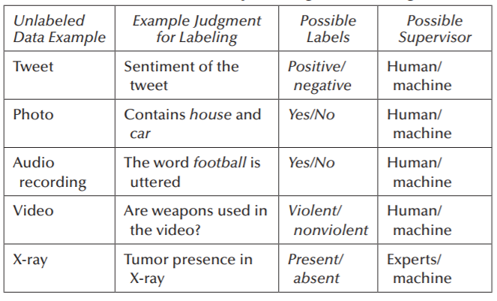

Table 1. Unlabeled data example

**Unsupervised Learning**

We do not have unattended managers or teaching information. All we have, in other words, is unlabeled data. The intention is to locate a hidden structure in these records. There may be several reasons why the findings are not important. This could be because the funds cannot pay for manual marking or because the information itself is innate. Data is now collected by multiple data storage devices at an unprecedented rate. Big data are calculated and measured in terms of variation, speed and volume. Nothing without the supervisor can be obtained from this material. This is the challenge for the new computer student. In a same manner as Alice's Adventures in the Wonderland (5:10), Alice does everything to talk to the Cheshire cat and faces a machine-learning practitioner.

… She will go on. She will go ahead. "What way can I say, please, from here?"

"How much depends where you can reach," said the Cat.

"I don't even care where," said Alice.

"So it doesn't matter the way you go," said Cat.

"As long as I'm going anywhere," said Alice.

"Oh, you know, if you're only going for long enough," Cat said.

The clustering of the learning population (unattended study algorithms) is similar to that of Cheshire. Regularities in the input can be contained elsewhere in Alice.

**SemiSupervised learning**.

The data are combined in this method of training with sensitive and unclassified data. In order to develop a viable data classification model, this categorised and unlabeled data mixture. Identified information is in most cases scarce and unlisted information sufficient (as described above in the unattended definition of learning). The aim of the semi-monitored classification is to create a model that can predict groups of possible trials better than the model developed using the labelised results. We are closely involved in the semicircular system of learning. 1. The child is confronted with unlabeled data from the environment. An unmarked data is filled in a child's setting at the beginning.

2. Info on labelling of the supervisor. For eg, by pointing out and saying their names, a dad teaches his children the names of the items.

The book does not examine more semi-monitored teaching.

**Reinforcement learning:**

This reinforcement strategy tries to take actions to improve or reduce the risk through environmental perspectives.

In improved learning, the following steps are used to develop smart programmes (also known as agents):

1. The input state is regulated by the handler.

2. The decision-making role applies to the behaviour of an agent.

3. After the action is taken, the agent receives environmental certificates or refurbishments.

4. State-action pairs have the reward statistics.

The policies for individual states can be optimised by applying stored information to make optimal decisions by our agent.

**Logistic regression:**

Logistic regression is a machine learning algorithm used for problem classification; it is an analytical analysis algorithm based on the concept of likelihood.

The logistic regression can be considered a model for linear regression, but logistic regression uses a more dynamic function that can be represented as the "Sigmoid function" or the "logistic one" rather than a linear function.

The theorem for logistic regression reduces the costs from 0 to 1. The linear functions therefore do not represent this because, according to the logical regression theorem, it can have a value larger than 1, or less than 0.

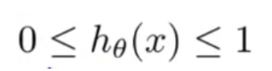

Which is Sigmoid's role?

The Sigmoid function is used to calculate predicted likelihood values. The function maps each true value from 0 to 1 into a different value. Sigmoid is used in machine learning to map probability predictions.

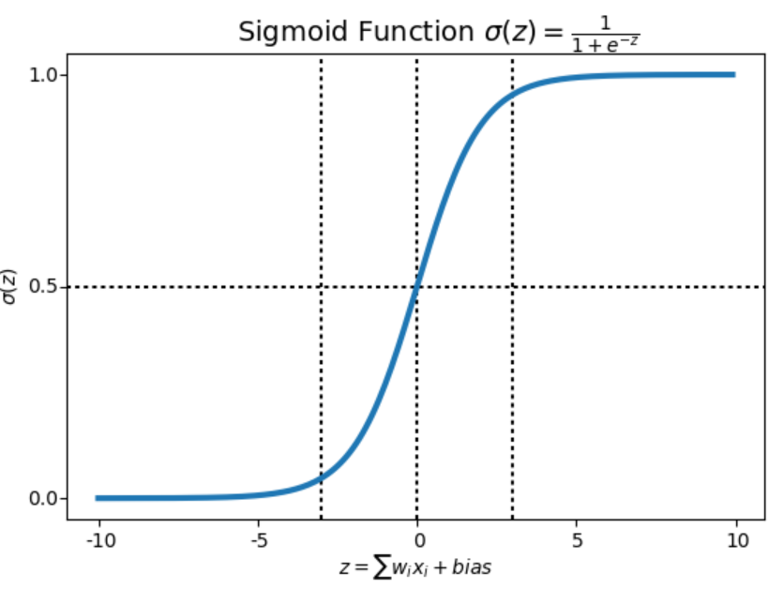

The logistic reverse of your data's distribution and relations is almost the same as linear reverse assumptions. Many of these theories were studied, and probability and statistical terms were used in great depth. I suggest using these as guidelines or thumb rules and playing with different data preparation systems.

Ultimately, instead of analysing results from mathematical modelling projects you focus on making accurate predictions. As such, certain assumptions can be broken, given the model is consistent.

Binary output variable: As we discussed before, this can be intuitive, but a logistic regression is a binary problem (two-class) with the classification. The probability of an instance rated as 0 or 1 in the default class predicts. Deletion of noise: logistic regression does not presuppose a flaw (y), considers the extraction of outliers from education data and potential misclassified cases. Noise deletion:

Logistic regression is a Gussian distribution linear algorithm: (with a non-linear transform on output). This supposes that the input and output variables have a linear relationship. Input variables data transformations that explain this lineary interaction more accurately. For example, you can use the log, basis, Box-Cox and other univariate transformations to expose this relationship.

Remove Associated Inputs: Like linear regression, the model can overfit if you have several strongly associated inputs.. Consider establishing the links of all inputs on a pair basis and excluding closely grouped inputs.

Non-convergence: the expected process of probability estimation would not lead to coefficients converging. This happens if the data has several strong linked inputs or if the data is very weak (e.g. lots of zeros in your input data).

**Naives Bayes:**

It is a classification technique based on the Bayes theorem which implies that predictors are separate. In plain words, the presence of any feature in a class does not relate to some additional role in a classification of Naive Bayes.

For example, an apple may be called because the fruit is red, oval, and 3 inches in diameter. Since these features are dependent on one another or any other features, these features independently add to the probability that it is an Apple and is thus considered 'Naive.'

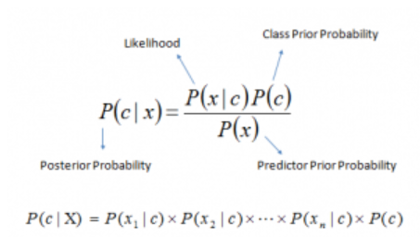

The Naive Bayes model can be easily constructed and is particularly useful for large data sets. In addition to the simplicity, Naive Bayes also provides very advanced grouping methods.

A route for Bayes's theorem P(c|x), P(x) and P(c|C). See the equation below:

P(c|x) is the predictor allocated to the retrospective class (c, aim) (x, attributes).

P(c) is the preceding opportunity of the class.

P(x|c) is a predictor's class chance.

The earlier likelihood of the predictor is P(x).

Pros:

The test data set class is fast to estimate and simple. It is also useful for multi-class prediction

If the classification of Naive Bayes is independent, it is better than other models, such as logistic regression, since less data is required.

The vector number of the input variables in the category is a good comparison (s). For the numerical vector standard distribution is considered (bell curve, which is a strong assumption).

Cons

If a vector category is not protected (in the test data set) the template assigns a probability of 0 (zero), but it cannot conjecture. The null frequency is sometimes named. We may use the smoothing procedure to correct it. Laplace Estimation is one of the simplest smoothing techniques.

On the other hand, Bayes has shown that it is a slow estimator and thus does not significantly forecast chance outputs.

Another downside for Naive Bayes is the assumption of independent predictors. Any fully autonomous predictors are almost unlikely in real life.

**Application from Naive Bayes**

Naive Bayes is a scientific classification, positive and certainly fundamental. It can then be used to render predictions in real time.

Multi-class prediction: also known because of its multi-class prediction. The chances of some goal audiences can be assessed here.

Spam filter analysis: Spam filtering: Spam filters Scan of spam Classification of text: Text rating The classification scheme of Naive Bays is mostly used as a classifier, because due to the multiple class problems and the freedom rules, the optimal result is more effective than other algorithms. Spam and sensational diagnosis are a popular use (spam identification) (in social media analysis, to identify positive and negative customer sentiments)

Proposal system: Collective scanning and the Naive Bayes Classification establish a mechanical education scheme and data mining techniques in order to exclude unrecognised contents.

**Decision Tree algorithm:** A shaft is made up of many actual analogies, and a wide classification area has been created for computer studies and reintegration. In decision analysis, a decision tree may be used to visually and precisely represent decisions. As its name goes, it uses a tree-like judging paradigm. But for a widely used data mining strategy there is a way to accomplish a certain goal, machine learning is always the first priority.

How is the algorithm tree represented?

Take, for example, a passenger's survival with titanic data or not. In the following model, three features, characteristics and pillars are used: (number of spouses or children along).

The Decision Tree is a supervised learning system that is also used for solving problems of classification and regression (s). The grading is organised into a tree where the internal nodes are part of the data collection and branches form the preference laws and every leaf node is the result.

The decision tree has two branches, the decision node and the leaf node. Decision nodes are used to decide and divide into several areas despite the fact that there are no nodes in the commodity leaf.

The decisions or evaluations depend on the data collection characteristics.

In these cases, the graphic representation depends on any option to solve a problem/decision.

It is called a decision-tab, because it starts with a tree-like root node and stretches through other branches to create a structure tree-like.

For tree construction use the CART algorithm, i.e. the algorithm Classification and Regression Tree.

The decision tree splits the tree deeper into sub-trees when addressing the question (Yes/No).

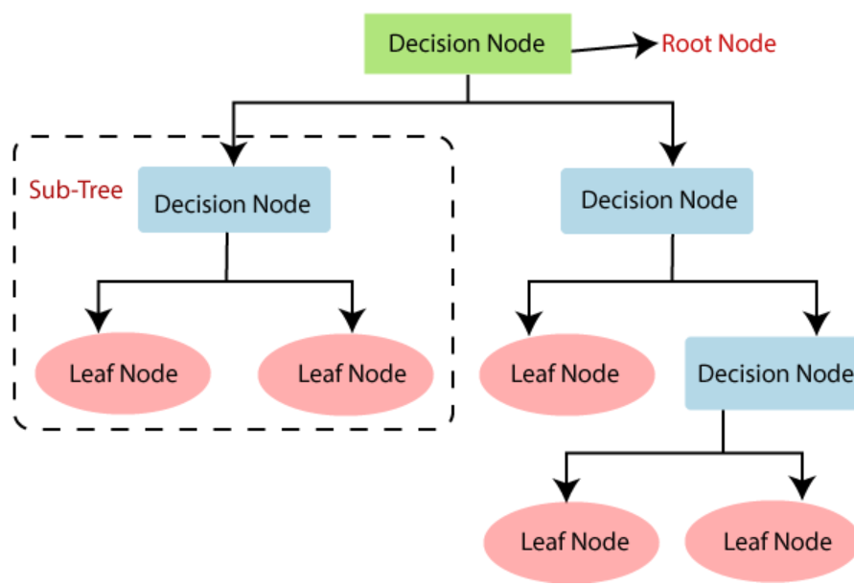

Fig1 Decision Tree algorithm

Upside down is a decision tree with its root. The black black text in the left image represents an internal node/composition where the tree splits into branches/corners. In this case, a decision/page is made as to whether the passenger died or survived and whether he or she was seen in red and orange. While a real data set will have a lot of features, it is just a branch of a larger tree, but it cannot neglect the simplicity of its algorithm. The importance of the role is clear and it is easy to see the interaction. The classification tree is called more frequently, since it is known to classify the living or deceased traveller, and is named above a tree. Regression trees are interpreted in the same manner that house prices forecast constant values. CART algorithms or regression and classification trees are commonly referred to as decision arboreal algorithms. But what happens in the background? A tree must mature together with information about the features and conditions to be used to separate. You would need to cut it to look beautiful as a tree arbitrarily rises. Let us start with a conventional technique of splitting.

The main subject of the decision tree is for characterising the configuration for the tree in which the significance of the trait is determined by each node, with each branch discussing the effect of the test. The tree leaves talk to the colleges. The figure indicates the selection tree evaluated from the project data set. The links to the set of data are shown.

Without important preparatory material, this approach is fast. There is little question about the probability distribution of these data.

Tree of Decision Proposed The method of tree building is called induction.

Building a decision tree:

The algorithm of the decision tree is a gay algorithm which means the tree that produces the leaves can be seen as being consistent.

Instead, isolating leaves in the same homogenous leaves as would be anticipated before a further division is feasible, is the real step in the algorithm. The algorithm is the following:

1. If the percentage of properties is continuously assessed, they will be classified.

3. If the evaluation dataset occurs in the same class, the event ends.

3. Choose the node from the individual characteristics which would best split papers and decide in the node.

**Random Forest:**

As its name suggests, the Random Forest consists of a vast number of separate decision-making bodies operating as a group. Every single tree in the random forest sprays a class prediction and our model prediction becomes the class with the most votes (see figure below).

Random Forest Model Visualization Make a forecast

A basic and influential philosophy behind random forest — the wisdom of crowds. The explanation for the random forest model to function so successfully in the field of data science is that many relatively uncorrelated models (trees), which operate as a comité, outperform all of the various constituent models.

The poor correlation between models is the main thing. Just when portfolios with low correlations (such as stocks and bonds) combine to form a portfolio that is larger than the total, uncorrelated models can provide a more exact set of forecasts than any single forecast. The explanation for this wonderful impact is that the trees guard against each other's mistakes (as long as they don't all walk in the same direction). While some trees might be incorrect, several other trees are right, so that the trees will go in the right direction as a group. The conditions for good performance of random forests are:

Our features need to provide a real signal such that models constructed with these characteristics are safer than a random devaluation.

There are poor correlations between the assumptions (and hence the mistakes) made by individual trees.

Random forests are a surveyed learning algorithm. It can also be used for regression and classification. The most robust and easiest to use algorithm. The park consists of trees. The stronger the woodland, the more trees he's got. It's said. Random forests create and forecast each tree randomly selected data samples, choose the best solution by vote. It also indicates the importance of the role very well.

Random forests have a variety of applications, including proposal engines, image descriptions and feature selection. This can be used for the distinction of trustworthy borrowers, extortion recognition and disease prediction. The algorithm Boruta is built on the basic functions chosen in the data collection.

Suppose you had to ask your mates and talk to them about their recent travel experience. Every friend's going to advise you. You now need to list the suggested sites. You then ask them to vote (or choose one of the better places for the trip) from their list of places. The place with the highest number of votes is your final choice for the tour.

The following decision-making process consists of two sections. Ask your fellow students about their personal travel experience first and get suggestions from those locations. This part is like the decision tree algorithm. Each friend here selects the places he or she has been so far.

The second step is the voting procedure to choose the best spot on the list of recommendations, according to all feedback. All the way to get tips and vote for friends is called the Random Forest Algorithm, so that we can choose the best spot.

It is a system of randomly distributed decision-making bodies theoretically. It is based on the divide and win strategy. This collection of decision trees is often called the woodland. A range and attribute metric, such as the gain of experience, the gain ratio and Gini index, is used to establish the different decision-making bodies. A random selection is used for the individual tree. The final outcome in a classification question is the choice of each vote on tree and of the most popular type. The final result is the average of all tree results with regard to regression. It's faster and better than other nonlinear grading algorithms.

How about the algorithm?

In four main phases it operates:

Select a random sample data package.

A decision tree is constructed for each sample and each decision tree provides for a prediction.

Check any prediction result for a vote.

Select the results with the most votes in the prediction.

Voting

Benefits: The number of decision-making trees involved in the project makes it highly detailed and resilient to random forests.

It's not an overfitting issue. The main point is that any projection, except the projections, is taken on average.

For both regression and classification problems, the Algorithm may be used.

Random woods can tolerate even missing values. There are two approaches: median variables are used to replace continuous variables and the near weighted average missing values are determined.

You will gain the relative importance to choose the most appropriate characteristics of the classifier.

Because few crucial trees exist, random forests are sluggish to produce forecasts. When a prediction is made, all the forest trees have to expect the same suggestions and then vote on it. In this step it takes time.

You would only make a decision by choosing a path to the tree compared to a decision box, and the paradigm is more difficult to grasp.

Significant features

Random forests also have a high selection indicator. An additional Scikit-learn variable is supplied to a model showing the relative importance or contribution of each function in the forecast. The appropriate score is automatically determined for each factor during the training phase. The relevance is then limited to a maximum of 1.

This score helps you to pick the main functions for model construction and decrease the least important characteristics.

The random forest uses a gini value or mean impurity reduction in the estimation of each feature's importance (MDI). Gini value is also referred to as the total reduction of node impurity. The reason is that if a part is lost, the model suit or precise. The larger the decrease, the larger the feature. The mean decrease is an important selection variable parameter in this case. A Gini index can be used to describe the overall power to illustrate the variables.

Random forests vs decision-making treasures

A lot of decision-making bodies are random woods.

Deep trees may be overflowing, but random forests prevent overflow by random subsets of trees.

Decision trees are computerised more quickly.

Random trees are difficult to read, whereas a decision tree can be read and converted into laws rapidly.

**K Nearest Neighbour:**

Neighbor K-Nearest is one of the simplest computer teaching algorithms based on the supervised approach.

The K-NN algorithm takes the new case/data compared with available cases and the new case is placed in the category that is more similar to the existing classes.

K-NN stores all possible data based on correlations and categorises them. This makes it easy to categorise the K-NN algorithm as a good suite when new data arrives.

The K-NN algorithm can be used for regression or classification, mainly the classification problem.

K-NN is a non-parametric algorithm which does not presume the underlying data.

The algorithm is often regarded as a pitiable student since the training package is not used but the data sets are stored, and the data sets are operated on while it is classified.

During the training phase, the KNN algorithm stores the data set and classifies the data in a category, much as the new data, if it receives new data.

# 4. Technical Implementation

# 4.1. Supervised Machine learning

Controlled deep learning is, in general, the strongest tool for calculating emotions. A collection of characters (a string) is a tool from the machine's viewpoint as a language text in natural language (some neural networks models can do this). Until a model is educated, the text is converted into a portable format, most generally a "function collection," which is displayed as an array of numbers. Each number represents a value for one of the set's features (a dimension). The characteristics must be defined before the text can be translated into a series of attributes. As the transformation element is performed, this is a precise move (however, most machine learning libraries have already implemented methods for this). The Words Bag division specifies the classification algorithms format for viewing data and database functionality, as well as providing additional technical information for the pre-processing phase.

# 4.2.1 Bag of words methods

A book is nothing more than a set of tokens. A word, a boom, or a string are all examples of tokens (number, other symbol, url, emoticon, etc.). A document may also be seen as a variable, with each entity in the document being counted by a symbol. Until individual records are translated into vectors, the whole dataset must be processed; otherwise, each vector has its own collection of functions, and the order cannot be comparable. To start, these two documents can be interpreted as the vectors below: (Table 1).

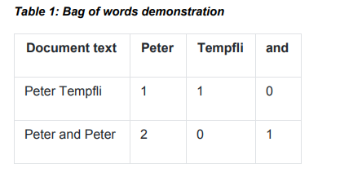

Table 2 Bag of words demonstration

Since we bring a term into a metaphorical 'box' where it doesn't position us while converting a text through a 'wordsack,' the method is named a 'wordsack,' and the vector doesn't say where a particular expression is on the paper – it only shows the count. A paper set is a matrix that represents text and term columns (tokens). Many computer students may use it as an input format since it is a multimedia platform (the data frame of other frameworks). It's worth noting that the array matrix view produces incredibly sparse matrices, which may cause problems for certain algorithms. While some architectures have mechanisms to solve the issue, this may cause memory bugs in some implementations. Another method for growing the amount of functions to the bare minimum. You may use advanced statistical techniques, filter tokens of low frequency, or restrict the number of tokens.

# 4.2.3. TF-IDF weighting

Due to an almost tailed word frequency distribution, the majority of texts which have certain phrases, while others are included in others. This causes a major disparity within the overall screen, in some cases affecting programme restrictions (dividing small numbers by very large numbers can result in numbers which are impossible to represent in a given software architecture, so some calculation simply can not be made). Multiple classifiers (Naive Bayes, for instance) will support this problem, but not all. Therefore, the Words Matrix bag is commonly used to standardise the frequency definition of the reverse text. The following function is used for any entity in the word bag matrix:



When tf returns the term frequency in a document and idf returns the national, reverse term frequency in the entire document package. The tokens are relatively unusual in simple terms, but are exclusive to a single text and achieve a high score.

# 4.2.4. Data gathering

From the database (appen.com, open source data 2016.05.25) the dataset is described as follows:

An description of the feelings of the problems of each major American airline. Twitter was scrapped and contributors were asked to recognise optimistic, negative and neutral tweets from February 2015, followed by negative explications (such as "late flight" or "rude service").

Feedback and research are also available in Kaggle in the same dataset. [www.kaggle.com, 11/5/2016].

The dataset contains 14640 rows and this work focuses on two columns: text and airline_sentiment. Text field contains the actual content of the twitter message, for example:

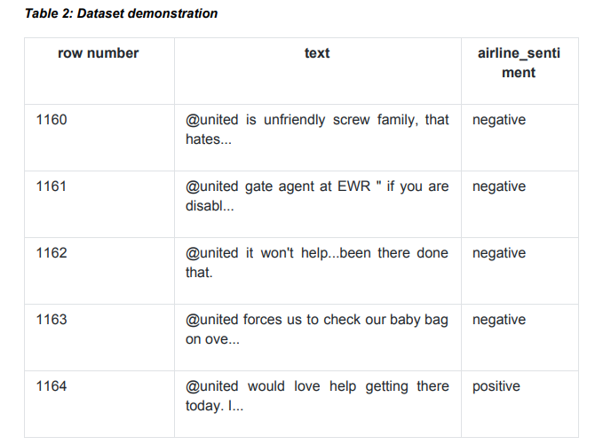

Table 2: List of sample words in the data

In this work other properties (id, dates, timezone, sentiment confidence) are not used for 2 reasons. Firstly, there is not enough documentation about these properties (how they are created). Secondly, using a too complex dataset as input would overly widen the scope of this research.

Airline sentiment field contains the sentiment of the tweet, which is a 3-type value: positive, neutral or negative.

# 4.2.5 Exploratory Data analysis

First step is to import all required libraries of the data:

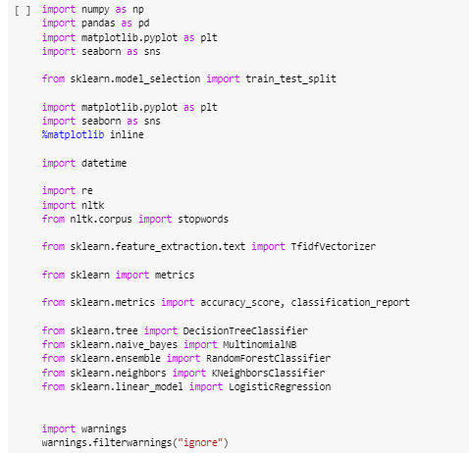

Next is to check the missing values in the data. Because this data may conatins many null values, after checking we need to drop all the null values in the data.

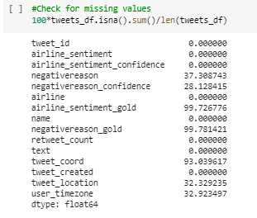

We observe that the missing values are more than 90%, the airline sentiment gold, negativereason gold and tweet coord, let us drop them because they provide us with no positive input.

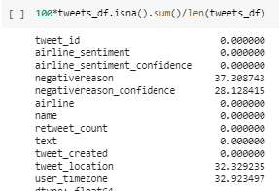

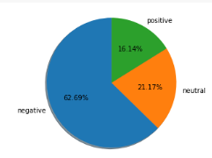

Fig 2 Pie Chart of percentage of emotions

From above, we see that we have the majority (63%), led by neutral (21%) and constructive feedback (16 percent )

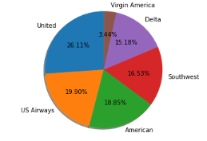

Fig3 Pie chart of Percentage of Arilines

1. Determine the cumulative number of tweets for each airline, and

2. determine how many of these tweets are derogatory, positive, or neutral for each airline.

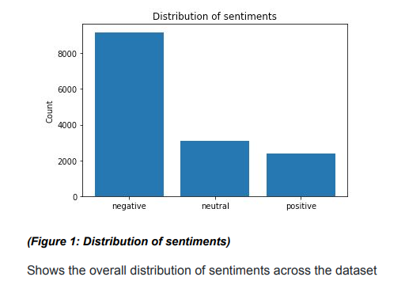

Fig 4 : Distribution of sentiments

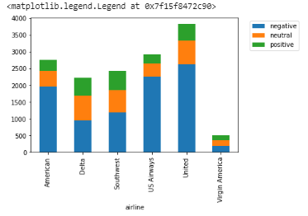

Figure 5. Distribution of airline sentiments

The graph above shows that United, US Airways and Americans have excessively negative tweets and that substantially more tweets have been sent in general.

Tweets are fairly balanced in Virgin America, Delta, and the South-West.

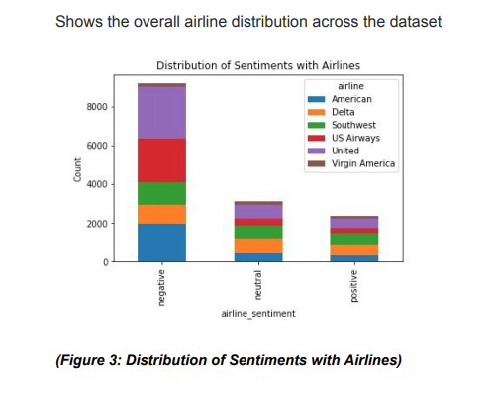

Fig6 Emotions of airlines with sentiments

The data processing in two dimensions is quite haphazard. It's worth mentioning. To begin with, a significant amount of tweets are deemed derogatory. Given the targeted dataset, this is a challenging training topic. In the segment on balancing data collection, we return to this problem. Second, data from different airlines cannot be compared. This would be obvious from business and marketing results (larger airlines tend to have more mentions). For example, the issue is that Delta passengers are much more optimistic than those in the United States, despite the fact that the total amount of good references is comparable. The bad news is that views aren't evenly distributed across airline subsets, which is a concern since a classification algorithm can deduce documents with the "Delta's" token. Although the designation itself must be neutral, this refers to how the training outcomes are processed.

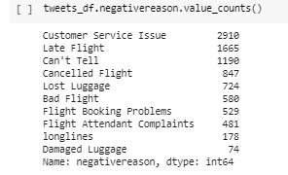

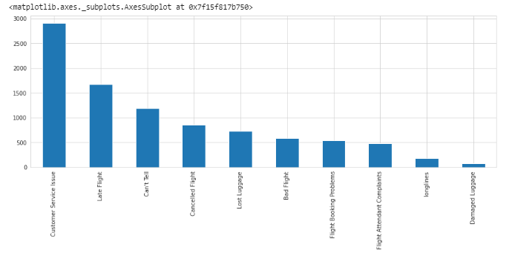

Fig7 Count of Bad reviews

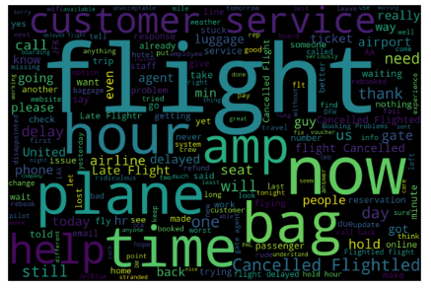

Fig 8 Wordcloud for negative statements

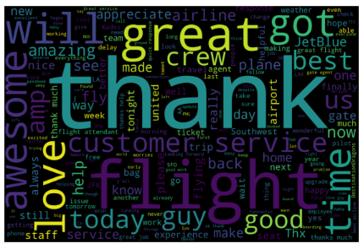

Fig 9 Wordcloud for positive statements

we observe that 'thank', 'flight', 'great', 'will', 'awesome' 'love' are present more frequently in positve statements.

# 4.2.6. Word frequency in the dataset

In the data set, the expression frequencies can be seen as the term life in the documents is used by the word representation bag. I might suggest that frequency would allow you more visibility into the results processing.

To begin with, it becomes apparent that so-called stopwords are the most frequent terms: syntactic tokens and other very normal words characteristic of data collection that have no classification value (however, the stopwords has a lot of meaning from the semantic point of view).

**Table 3: Word frequency with stopwords in the dataset**

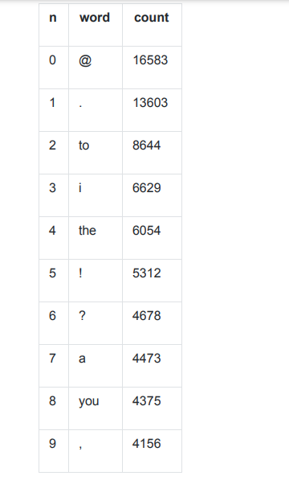

These tokens are obviously not omitted from this dataset: the top token frequency will be equivalent in any random English dataset. Such "extreme frequency terms" must then be removed in order to see words unique to the domain's data set. This is accomplished by removing the common stop word and excluding those common terms found in the data set (typically approaches are included in several of the language processing software packages). This is a manual process: the findings should be shown, and the amount of stop words should be minimized. The dataset takes on a different look after the filters avoid term transformation. It is undeniably more traditional in the aviation sector.

**Table 4: Word frequency with stopwords in the dataset**

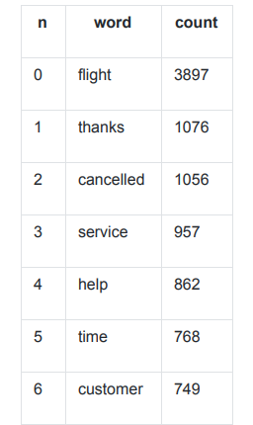

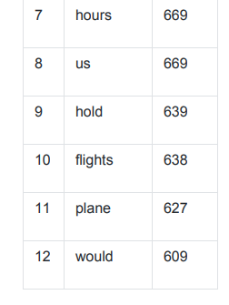

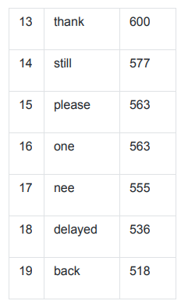

# 4.2.7 POS distribution in classes

A portion of the distribution of language in a text is quite constant (since it's big enough), but the exact distribution shape varies between various types and genres and also among writers, including Noun, Adjective, Personal Pronoun, Playing and Determiner. Given this, it is useful to examine the part of speech distribution between different pre-labeled sentiment classes.

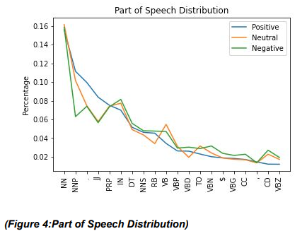

Fig 10 Part of Speech Distribution

The spoken composition of the groups has major variations. For example, positive (true) tweets have a NNP of 11%, whereas pessimistic tweets have a NNP of just 6%. The JJ number fluctuates a lot of positive and negative percentages (8.3 percent and 5.6 percent ). The majority of negative messages seem to be negative (IN). This, in my mind, exemplifies the details transmitted by POS markings.

# 4.31. Comparison of the predefined classes

If a predetermined data form array is used as a model training data set, there is serious doubt: how accurate is the data set? There are some questions in the nostalgic analysis for predefined categories: how accurate are the document class boundaries? This topic is illustrated in this article by a feeling research engine. The same findings were gathered. The outcomes are then compared to the categories that were selected.

This is why Amazon interpretation is included (Amazon Comprehend, n.d). "Amazon Comprehend evaluates a document or a sequence of papers using a role model. According to the article's description. This model has been consistently trained on a wide range of texts.

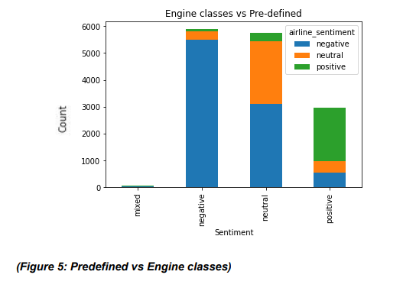

**(Figure 11: Engine classes vs Predefined)**

Overall, there is a 67 percent match score. More intriguingly, it is not the same distribution of non-comparable groups. Many emotional engine groups are pessimistic and positive, but there are a lot of neutral styles. This pattern can be found in both plots (Predefined vs Engine classes and Engine classes vs predefined). The Amazon Comprehension engine is generally listed as neutral in more important texts. For the class rating, the engine offers cluster confidence-based data points. The engine's reports include an average neutral ranking of 0.79. Documents that are categorized as Neutral by the motor but are classified negatively in the data collection (due to a mismatch in the classes) are rated 0.75. 0.84 is given for documents labeled as neutral and predefined as neutral.

From this the following conclusion can be drawn: the predefined classes are not necessarily faulty (or, the engine is not necessarily wrong); rather that the boundaries between classes are on different positions. In a classification problem like sentiment analysis this is absolutely acceptable, as there are no strict borders between sentiments. Pang and Lee conclude (Pang and Lee, 2002, Volume 10 (pp. 79-86)) that machines outperform humans with classification; so even though different models can give different results, it is still more feasible to use automated sentiment analysis than manual classification.

# 4.3.2 Building the right training dataset

It is important to use managed machine learning approaches to set defined data sets of targets in order to train (or suit) the classifier model. Another dataset is needed, which the classificator does not present during research. As a result, the qualifying classification's output on invisible data should be checked before it is used in development. Present goal data is compared to the predictions of a qualified classifier through this evaluation. It's as simple as counting the correct forecasts or utilizing advanced metrics like precision, selectivity, and F1 ranking (so that we can obtain an average percent). When a serious overwrite happens, the classificator "knots" these data and "learns" the classificator, making it difficult to determine the training data classification. This is the correct dataset for the test:

● Has the same feature and target distribution as the training dataset.

● On the other hand, it is also beneficial to test the model performance on a training dataset which has relatively small differences in targets. The rationale behind this is that way it is possible to test model performance for rare cases, not only for the common ones.

● Is large enough, so the randomness of outcomes is relatively small

● On the other hand, it is not too large, because there is a trade-off between the training set and the test set. The more data to test, the less is to train, and the model performance can suffer.

There are no clear definitions about what is a good size for a test set, because, as we see, there are many factors. The decision heavily depends on the size of available data, on the characteristics of this data and on the domain.

# 4.4 Pre-processing

Text (document) pre-processing is a method for translating text data into a particular output format. The simplification and normalization of the text in order to minimize ambiguity is the core objective (from the model point of view). These are usually basic, regulatory and delete activities. However, there is a different preprocessing approach that renders documents richer with the introduction of characteristics. This transactions typically use a certain linguistic formula for an external model or data collection. The preprocessing protocol can be chained together as a basic input/output feature. It is valuable since steps can quickly be added or omitted from an implementation point of view. Measures must therefore be taken prior to the addition of deleted steps (simplifying, normalizing). The next section focuses on the pre-processing phases.

# 4.4.1. String Normalization

This step includes all the common regular expression based operations, such as

● lowercase conversion

● number removal / converting to words

● punctuation mark removal

● white space removal

This is an important step, as makes the documents more approachable for tokenization by removing a lot of 'noise'.

# 4.4.2. Tokenization

During the tokenization, the document is split into words, so the function returns a list of words. It might look that this is a trivial step but some ambiguous cases may occur. For example,

● What to do with hyphens? Is High-rise building two tokens or three?

● There are entities, which should be one token, but using simple rules they might be split up. IP numbers, car model names, phone numbers... Entity recognition is always a domain-related problem.

● This also can be a language-specific problem. For example, German language uses a lot of compound nouns, such as Rechtsschutzversicherungsgesellschaften. Here stemming can be a solution.

It normally involves removing URLs, stopwords, and words, as well as reversing words with recurring letters, replacing negative references, and expanding the acronym to the original term. When introducing the tokenisation stage, the specifications should typically be taken into consideration. Advanced tokenization algorithms are typically set up.

# 4.4.3. Stopwords

A stopword is a rather vague term with little real meaning. Filtering these words removes noise and helps you to pinpoint specific records. Stopwords are special to languages and domains; the latter list is usually customized to a specific problem by hand. When struggling with classification and mathematical methods, filtering stopwords is typically a good strategy. And there might be instances where dropping traditional stopwords is challenging. For eg, the term President of the United States would be reduced to a President of the United States kind, which isn't too helpful as a designation. That is most likely ineffective.

# 4.4.4. Stemming / Lemmatization

Each term appix is absent, leaving only the word's origin. This is the morpheme root that many people are unable to understand. Lemmatization, which is the dictionary version of the expression, is a similar way of minimizing lemma terminology. There are two things that must be included with this. To begin with, it is not a particularly significant shift in English since the language's agglutinative tendencies are comparatively small. It is, however, a crucial phase in languages with a number of word alteration trends (e.g. Slavic or Latin). The majority of surveys, As in Indonesia, influences of the stemming impact analysis of Indonesian tweet sentiments (Hidayatullah 2015). System in computer science and IT, 2(1), pp.127-132) and between non-English and English texts shall be maintained Arabic (Wahbeh and al., 2011).

Secondly, the same simple wording is limited to two separate words, which "reduces the high dimensions of the function space in text classification" (Wahbeh and al., 2011). It can be helpful, but papers with several types of critical features can be difficult to discern.

# 4.4.5. N-gram converting

To create a tokens list is just one script option. An option is to mention the n-gram documents, 'since in previous works solid results were collected.' (The robust sensitivity of partial noise data tweet detection (Barbosa and Junlan 2010). Postings of the 23rd Electronic Linguistics International Conference (pp. 36-44) The n-gram is the set of n tokens. (for instance, brown fox) is 2 g (bigram). The statement Two grammes are seen as the fast brown fox flows across the lazy dog: (The, quick), (Fast, brown), (Brown, fox) (fox, jumps)...

The declaration can also be represented in three grammes: (The, fast, brown), (quick, brunette, fox) (brown, fox, jumps)...

This representation of documents can be beneficial because larger chunks of information can be used as a document feature. For example, when using 2-grams, the brown fox is a term, which can be found around the corpus. The size of n-grams depends on the problem, but in nature language problems rarely use larger than 3-grams. The cons about using n-grams is that it creates more features, which might lead to performance issues.

**Infrequent word filtering**

In paper classification issues, words that occur infrequently or just once have little significance as predictive approaches. These terms can be withdrawn. Since features smaller than the whole body can be accessed, memory and CPU resources are saved. Experiments reveal that maintaining the top 1,000 words has little effect on grading ratings, whereas having them at the top 3,000 has a negligible effect.

# 4.4.6. Synonyms

It could be beneficial to translate synonyms into a more common expression, since a collection of odd words will then be given a more usual name. An external dictionary is also needed for this. Some claim that "significantly different emotional analysis scores for terms that are often stylistically different" are the product of "significantly different emotional analysis scores for words that are often stylistically different." 2018 (Shen and Rush) Slave labour

# 4.7.7. Part of Speech tagging

According to some scientists, using speech data as an additional function would increase classification performance: 'Previous approaches have shown that using POS tags [for this task] is effective. Any POS tag will act as a decent indication of how you're feeling. (Riloff & Wiebe, 2005,Create grouping from non-annotated texts, subjective and objective. International Computer Linguistic Conference and Smart Text Analysis (pp. 486-497))) (Barbosa and Junlan, 2010). Obviously, diverse POS distributions in the Datasets segment have been used in tweets from numerous groups. However, it's uncertain if attaching POS tags will boost its own efficiency. For the purpose of this claim, there are a number of tests that limit tokens to POS tags only. After removing all other detail, a classifier trained on this data set still outperforms an utter random conjecture.

# 5. Model Building

The experiment investigates the utility of various classification schemes with various text preprocessing choices. The aim is to build the right combination of classification algorithms and text preprocessing for two datasets: a strong (positive/non-negative) three-class data structure and a good (positive/non-negative) two-class data structure (positive-negative-neutral). Since randomness is reasonably narrow if it is tested, a training range of 30% tends to be a realistic approach, as seen in the test segment.

In order to compare different test sizes, a following algorithm is used:

● Split the dataset into 2 parts : train set and test set with a proportion for test part X

● Train a classifier model on the train set.

● Predict the classes using a Naive Bayes classifier for the test set; the proportion of correct outcomes would be S (score)

● Map S to X

● Repeat the following steps for every X between 0 and 1

(There is certain randomness in this function, because the split of test and train sets is random. In order to eliminate this, S is calculated 10 for every X and finally an average is taken) These steps describe a function, which can be plotted. Various datasets yield different shapes.

These are the key findings:

The function must be drawn for three datasets. Two categories balance the positive and bad, and the three forms are balanced by the same three grades. The whole dataset is unrivaled (positive, neutral, negative)

The test results for a broader teaching spectrum are clearly better.

● At the beginning of the novel, there is a significant decline. In this case, the hidden data method 'learns' to rename the overfit sector. Two-class data set receives the highest marks. After overposition, a steady score of 85 percent is achieved; after a certain stage, the score begins to fall in a steep line (about 20 percent of the train set). A 2-degree classification is simple except on a small scale. The average score for a balanced three-class data set is smaller, but the practical type is the same. The decline, on the other side, is more substantial. We might infer that for a more complex dataset, a larger kit is easier (more classes).

● The unbalanced dataset includes many trends. In comparison to the train number, the score decreases. Additional test results must usually guarantee that the "true and unbalanced" data set is compared as closely as possible.

From the findings above, one can conclude that a 30% test size can be used in the following experiments. One can see on the plots that at 30% test size both balanced and unbalanced dataset almost don't suffer anything on scores compared to smaller test sets.

# 5.1. Classifiers

The following classifiers are used in the experiment:

* Logistic regression
* Random forest
* K Nearest neighbours
* Naive Bayes classifier
* Support Vector Machines

# 5.2. Pre-processing datasets

Each text is standardized using a template (removed whitespaces, turned to lowercase). Following the implementation of the following preprocessing techniques. These methods are used to obtain and return the same text type, making it possible to connect these functions. To start, a study should incorporate stemming and N-gram conversion. To ensure that the results are similar, the following preprocessing procedures are used, and the same procedure is repeated. Preprocessing methods may also be joined together in a series.

● Stop-word filtering (common stopwords and domain specific)

● Keeping only top 500 tokens

● 2-Gram conversion

● 3-Gram conversion

● Stop word removal and stemming

● POS-tagging

# 5.3. Comparison matrices

After running all the classifiers with all the preprocessing methods, the following outcomes are generated.

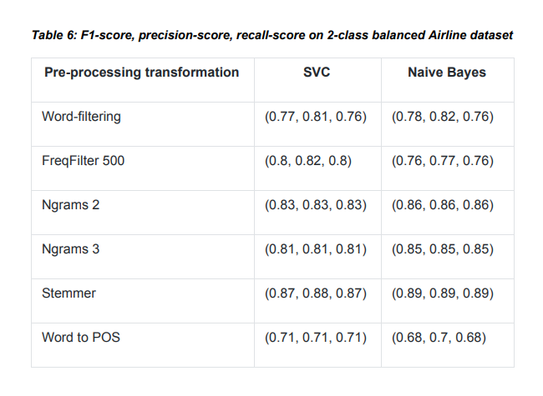

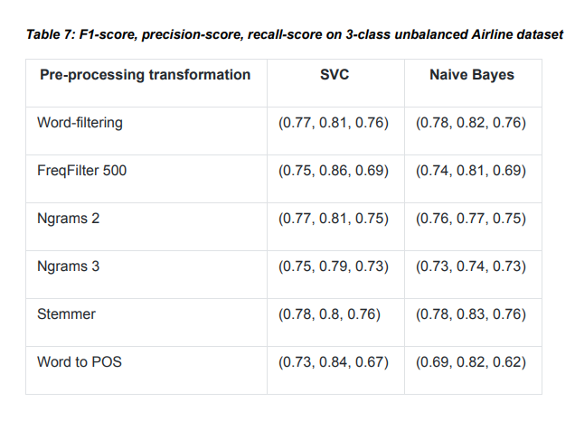

Experiments in various configurations yield varying effects, as seen in Tables 6 and 7. (Table 6 and 7). The following segment reflects on the general topics of these findings. The same experiment was conducted to track this experiment in two separate data sets (Go, Bhayani, and Huang, 2009,Twitter sentiment classification using distant supervision. CS224N project report, Stanford, 1(12), p.2009), and very similar patterns were noticed.

Naive Bayes classification systems provide the strongest results on well-balanced datasets. To make any expression clearer to their source, the quickest filters are used to delete stopwords (Stemmer classifier). It's important to note that there are two methods for filtering stopwords: standard, language, and domain-specific. Both are a part of the analysis. Language stopwords could be filtered using virtually any standard linguistic processing system; however, domain stopwords will have to be customized to the latest datasets. A more sophisticated preprocessing approach of well-balanced data collection does not improve efficiency, and almost every configuration of Naive Bayes classification systems beats SVC. It's worth mentioning that as the number of features reduces, vector machine support rises (speech tags or word frequency filters). The compromise is a worse estimate.

As part of a broader, unbalanced experiment (as the number of individual groups is different). More interesting, Vector Machines nearly always supports Naive Bays on these datasets. It's also worth mentioning that, although the binary pre-processing data set changes in a balanced way, the same cannot be said with the same imbalanced dataset with a significant improvement in prediction ratings. The discrepancy between the best and worst predictions of the aligned dataset is 21%, but for the unprecedented results, the difference is just 5%. To grasp model behavior and monitor performance, it's best to look at essential functions (Tables 8 and 9) in data sets (words).

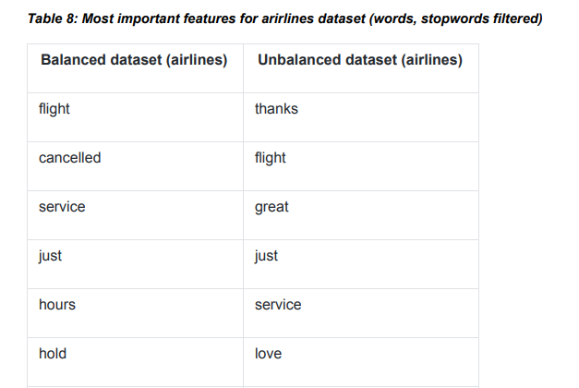

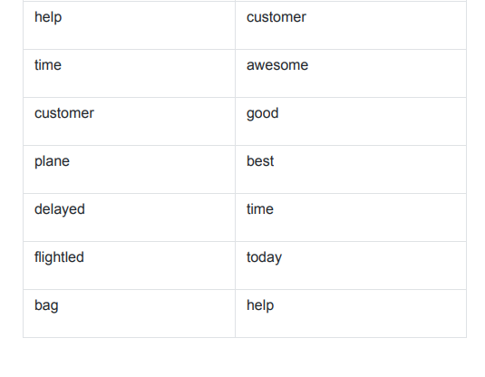

Filtering stopwords as well as domain-specific stopwords is important, as it improves prediction scores. Analyzing the top features (Table 8) show that different datasets have very different top-features, and for the airlines-dataset it is arguably very much domain specific.

**Table 9: Most important features for comparison dataset (words, stopwords filtered)**

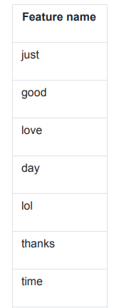

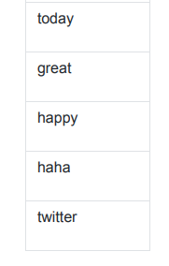

Comparing airline dataset’s top features to the control dataset show that although there are some common top-features (which are specific to the language itself), most of features (and their order, i.e. the prediction power) are very different. It means that a model trained on one dataset is not necessarily can be used on another dataset.

# 5.4.1 Logistic regression:

The goal is to find the most suitable model to describe the association between a number of independent variables and a dichotomous interest attribute. It's a mathematical technique for evaluating a data set in which one or more independent variables influence the result. A dichotomous variable is used to assess the result.

The accuracy score of the logistic regression was 79.1% which is good, this algorithm predicts the emotions of the tweets. Here you can see the precision score, recall and F1 score for different classes such as negative, neutral and positive. Coming to the precision score the highest score achieved for the negative where the text prediction accuracy is high for the negative statement whereas recall and f1- score scores also predicts the negative statement high which their scores are high compared to the other classes. Next highest prediction occurs for the positive statement where the precision score is 60%, recall score was 81% and F1- score is 69%.

LogisticRegression Accuracy Score : 79.1%

precision recall f1-score support

negative 0.93 0.81 0.87 3232

neutral 0.48 0.66 0.56 648

positive 0.60 0.81 0.69 512

accuracy 0.79 4392

macro avg 0.67 0.76 0.71 4392

weighted avg 0.83 0.79 0.80 4392

# 5.4.2 Multinomial Naive bayes:

The NB classifier is a classification technique based on the Bayes theorem and the theory of predictor freedom. The Naive Bayes model is simple to construct and is particularly useful for massive data sets. Naive Bayes even exceeds the most complex classification processes because of its flexibility. The final model will display a high level of success and planning and assess the probability of using the Gaussian Naive Bayes classification scheme with a Zk type characteristic.

The accuracy score of the Multinomial NB was 69.69% which is good, this algorithm predicts the emotions of the tweets. Here you can see the precision score, recall and F1 score for different classes such as negative, neutral and positive. Coming to the precision score the highest score achieved for the negative where the text prediction accuracy 99% which is high for the negative statement whereas recall is 69% and f1- score 81% scores also predicts the negative statement high which their scores are high compared to the other classes. Next highest prediction occurs for the positive statement where the precision score is 18%, recall score was 93% and F1- score is 31%.

MultinomialNB Accuracy Score : 69.69%

precision recall f1-score support

negative 0.99 0.69 0.81 4081

neutral 0.15 0.78 0.26 174

positive 0.18 0.93 0.31 137

accuracy 0.70 4392

macro avg 0.44 0.80 0.46 4392

weighted avg 0.94 0.70 0.77 4392

# 5.4.3 Decision tree algorithm:

Every internal node is a test on an attribute and each branch is a test result, with every node being a class. It's a tree structure that looks like a flow map. A decision tree constructs the Tree System level classification or regression models. It separates a number of data progressively into smaller and smaller subsets, thus creating an appropriate assessment tree. A boom of decision nodes and leaf nodes is the end product. The root node is the top decisive node in a tree that corresponds to the best predictor. The accuracy score of the Decision tree was 67.42% which is good, this algorithm predicts the emotions of the tweets. Here you can see the precision score, recall and F1 score for different classes such as negative, neutral and positive. Coming to the precision score the highest score achieved for the negative where the text prediction accuracy 79% which is high for the negative statement whereas recall is 78% and f1- score 79% scores also predicts the negative statement high which their scores are high compared to the other classes. Next highest prediction occurs for the positive statement where the precision score is 55%, recall score was 57% and F1- score is 56%.

DecisionTreeClassifier Accuracy Score : 67.42%

precision recall f1-score support

negative 0.79 0.78 0.79 2841

neutral 0.40 0.41 0.40 879

positive 0.55 0.57 0.56 672

accuracy 0.67 4392

macro avg 0.58 0.58 0.58 4392

weighted avg 0.68 0.67 0.67 4392

# 5.4.4.Random Forest:

Random forests are a series of training programmes for ranking, regression and other tasks, also known as random forest decisions, operating during planning and distribution into a classroom of the average predictor for individual trees for installation of various decision-making bodies. Random woods reinforce the decision-making bodies' willingness to exceed their teaching. The accuracy score of the Random forest was 76.78% which is good, this algorithm predicts the emotions of the tweets. Here you can see the precision score, recall and F1 score for different classes such as negative, neutral and positive. Coming to the precision score the highest score achieved for the negative where the text prediction accuracy 94% which is high for the negative statement whereas recall is 79% and f1- score 86% scores also predicts the negative statement high which their scores are high compared to the other classes. Next highest prediction occurs for the positive statement where the precision score is 54%, recall score was 79% and F1- score is 64%.

RandomForestClassifier Accuracy Score : 76.78%

precision recall f1-score support

negative 0.94 0.79 0.86 3378

neutral 0.38 0.63 0.48 535

positive 0.54 0.79 0.64 479

accuracy 0.77 4392

macro avg 0.62 0.74 0.66 4392

weighted avg 0.83 0.77 0.79 4392

# 5.4.5 K Nearest neighbour classifier:

It's a straightforward algorithm that saves all available cases and classifies new ones based on the votes of its k neighbours.

The case that has been assigned to the class is the most common among its K closest neighbours, as determined by a distance function. Euclidean, Manhattan, Minkowski, and Hamming distances are examples of distance functions. Continuous functions are represented by the first three functions, while categorical variables are represented by the fourth function. If K = 5, the case is simply assigned to the class of the case's closest neighbour. When doing KNN modelling, selecting K can be difficult at times.

The accuracy score of the KNN classifier was 69.83% which is good, this algorithm predicts the emotions of the tweets. Here you can see the precision score, recall and F1 score for different classes such as negative, neutral and positive. Coming to the precision score the highest score achieved for the negative where the text prediction accuracy 82% which is high for the negative statement whereas recall is 80% and f1- score 81% scores also predicts the negative statement high which their scores are high compared to the other classes. Next highest prediction occurs for the positive statement where the precision score is 53%, recall score was 65% and F1- score is 58%.

KNeighborsClassifier Accuracy Score : 69.83%

precision recall f1-score support

negative 0.82 0.80 0.81 2866

neutral 0.46 0.42 0.44 960

positive 0.53 0.65 0.58 566

accuracy 0.70 4392

macro avg 0.60 0.62 0.61 4392

weighted avg 0.70 0.70 0.70 4392

# 6. Result analysis:

Result has been obtained by all the classifiers such as Logistic regression, Navies Byes, K nearest neighbour classifier, random forest classifier and decision tree classifiers and finally among all these algorithms logistic regression achieved the high accuracy with 79.1% and also precision and recall score are also high compared to other algorithms. And secondly random forest got a good accuracy of 76.69% which is similar to the logistic regression accuracy, here the precision score, recall and F1-score are also quite good. And remaining algorithms such as Multinomial NB classifiers, Decision tree and KNN got similar accuracy and these are not reached to the 70% and also the score for the classification report are also quite low. Among all these algorithms I felt logistic regression is the best one with good accuracy.

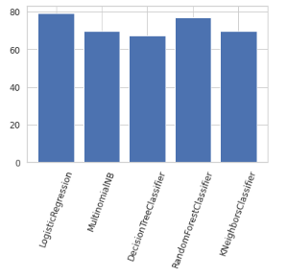

Fig 12: Accuracy scores of classifiers

Output prediction:

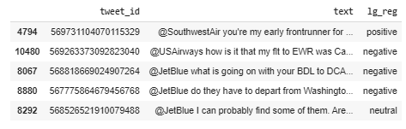

# 7.Conclusion and Discussions:

Twitter has risen to prominence as the world's leading online customer support network in recent years. The Twitter Airline Sentiment dataset is used in this study, and more than 60% of the derogatory responses are just expected. As a result, the negative tweets are analysed, and a negative wordcloud is generated. United airlines services had the most tweets, led by US airway and American airlines services, according to the dataset. Negative comments were more prevalent in United, US Airways, and American Airlines, while negative comments were less prevalent in Southwest, Delta, and Virgin America. The two most common explanations for unfavourable customer feedback about airline facilities are customer care problems and late flights. Due to customer service questions, US Airways has the largest proportion of derogatory tweets. Customers' issues can be known to airline services for resolution, and customers' locations can be plotted using graphical mapping. The best sentiment classifier, which is the Random forest classifier, was chosen after the seven classification methods were compared for Twitter sentiments of airline services. This classifier can be used in airline services market intelligence programmes to classify customer satisfaction with airline services automatically.

Sentiment analysis is typically a very domain-specific setting, since there is no best configuration for any complexity. Similar approach (building improved output classifiers in real-life sentiment experiments, comparing various classification methods of feature selection) may be quite helpful in the current article. Any commercial versions of the sentiment analysis software do not support the fine tuning functionality included in this piece. As an additional work, the author sees the following possibilities:

A form of experimentation that will work in tandem with company tools to enable consumers and operations to customize the feel analysis program to their own tastes. Skewed training data sets and wrong stopword settings for scores are drastic, as the experiment indicates, and these fixing procedures are not included in the majority of industrial implementations, despite the fact that they may provide substantial advantages in the implementation of a solution. Sensational analysis is obviously not restricted to social media, it can be extended to virtually every natural text.

All of the classifiers, including logistic regression, Navies Byes, K nearest neighbour classifier, random forest classifier, and decision tree classifiers, generated similar results, with logistic regression achieving the highest accuracy of 79.1%, as well as precision and recall scores, when opposed to the other algorithms. Second, random forest has a decent accuracy of 76.69 percent, which is close to the accuracy of logistic regression; the precision score, recall, and F1-score are all excellent. The remaining algorithms, such as Multinomial NB classifiers, Decision tree, and KNN, achieved comparable accuracy but did not exceed 70%, and the classification study score was also very poor. Of all of these algorithms, I believe logistic regression is the most accurate.

The experiment shows that different datasets behave differently when it comes to emotional processing. Because the data set, case studies, and data style may have a direct impact on the outcomes, they must be considered.

● It's quick to grasp, and it's simple to spot secure information. Actual data, on the other hand, is often unbalanced, and often classifiers will depend on unrivaled data. Re-balancing the data could be a viable option if the volume of data is too big (i.e., sampling equivalent amounts of cases in each class). The sample size analysis section reveals that there is insufficient data to represent the entire data collection.

● According to certain findings, the most successful approach to sentimental research is to use Random forest, Logistic regression, Multinomial NB classifier, KNN and Decision tree classifiers. To boost the performance parameter of tuning techniques, TL-IDR mapping on the term bag feature and grid analysis on the classifier parameters may be used. Grid search greatly expands the training cycle, enabling it to execute pN instead of only one.

● Stopword filtering improves pre-processing documentation prediction rates.Sometimes, domain-specific stop words boost preview scores, but it often necessitates the use of manual data sets, which avoids the automation and frequency of domain-specific data. When it comes to top functionality, the majority are domain-specific. Although constructing a generalized emotional prediction model is difficult, it can also learn to solve a problem using its own classification model. The small range of functions restricts predictive ratings, but this is unlikely to be a major issue for today's computers. However, there may be a need for usage cases. The sophistication of the algorithm, for example, greatly decreases research (for instance, grid space analysis parameters and neural network modelling).

Clearly, generalizing any of the above results across all datasets is incorrect. It's important to understand that changing the sensing parameters is a key move in dramatically altering some outcomes. However, since the findings are identical to those published in the literature, they may be a useful benchmark for potential analysis.

# References

Agarwal, A., Xie, B., Vovsha, I., Rambow, O., and Passonneau, R.J. Twitter data sentiment review. The Workshop on Language in Social Media (LSM 2011) published its proceedings (pp. 30-38).

Open Source Datasets, Appen.com https://appen.com/resources/datasets/,

https://docs.aws.amazon.com/comprehend/latest/dg/how-it-works.html, Amazon Web Services, 2020.05.25

L. Barbosa and J. Feng, 2010. From skewed and noisy results, robust sentiment detection on Twitter. Posters from the 23rd international conference on computational linguistics are included in the proceedings (pp. 36-44). The Association for Computational Linguistics (ACL) is a non-profit organisation dedicated to the study of language

A. Bifet and E. Frank, 2010. Twitter streaming data is used to explore sentiment information. In a forum on discovery research held around the world (pp. 1-15). Heidelberg and Berlin: Springer.

K. Dave, S. Lawrence, and D.M. Pennock, 2003. Opinion analysis and semantic classification of advertising feedback from the peanut gallery. The 12th international conference on the World Wide Web is published in the proceedings (pp. 519-528).

D. Davidov, O. Tsur, and A. Rappoport, 2010. Twitter hashtags and smileys were used to improve emotion learning. Posters from the 23rd international conference on computational linguistics are included in the proceedings (pp. 241-249). The Association for Computational Linguistics (ACL) is a non-profit organisation dedicated to the study of language

A. Go, R. Bhayani, and L. Huang, 2009. Distant supervision for Twitter emotion grouping. Stanford, 1(12), p.2009, CS224N project study.

A.F. Hidayatullah, 2015. Stemming's Impact on Indonesian Tweet Sentiment Analysis 2(1), pp.127-132, Proceeding of the Electrical Engineering Computer Science and Informatics.

Z. Jianqiang and G. Xiaolin, 2017. On Twitter sentiment analysis, a comparison study of text pre-processing methods was conducted. IEEE Access, vol. 5, no. 5, pp. 2870-2879.

Kaggle.com US Airline Sentiment

2020.05.25, https://www.kaggle.com/crowdflower/twitter-airline-sentiment

M.V. Mäntylä, D. Graziotin, and M. Kuutila, 2018. A survey of research subjects, venues, and top-cited articles in opinion analysis. Computer Science Review, vol. 27, no. 1, pp. 16-32.

A. Pak and P. Paroubek, 2010. As a corpus for sentiment analysis and opinion mining, Twitter is included. LREc (Large-Scale Reciprocal (Vol. 10, No. 2010, pp. 1320-1326).

B. Pang, L. Lee, and S. Vaithyanathan, 2002. Machine learning methods for emotion classification get a thumbs up. In the Proceedings of the ACL-02 Conference on Applied Linguistics,

Volume 10 of Empirical Approaches of Natural Language Production (pp. 79-86). The Association for Computational Linguistics (ACL) is a non-profit organisation dedicated to the study of language

R. Parikh and M. Movassate, 2009. Various classification methods were used to analyse the sentiment of user-generated Twitter notifications. Final Report, CS224N, p. 118.

H. Saif, M. Fernandez, Y. He, and H. Alani, 2013. A survey and a new dataset, the STS-Gold, were used to evaluate datasets for Twitter sentiment analysis.

H. Saif, Y. He, M. Fernandez, and H. Alani, 2016. Contextual grammar for Twitter sentiment analysis. 5-19 in Information Processing & Management, vol. 52, no. 1.

J.H. Shen, L. Fratamico, I. Rahwan, and A.M. Rush, 2018. Is she a darling or a babygirl? In emotion research, stylistic distortion is being investigated. In the 5th Fairness Workshop,

Machine Learning Accountability and Transparency (FATML).

B. Snyder and R. Barzilay, 2007. The good grief algorithm is used to rate several aspects. Human Language Technologies 2007: The Conference of the Association for Computational Linguistics' North American Chapter; Proceedings of the Main Conference (pp. 300-307).

A. Wahbeh, M. Al-Kabi, Q. Al-Radaideh, E. Al-Shawakfa, and I. Alsmadi, 2011. Wahbeh, M. Al-Kabi, M. Al-Radaideh, Q. Al-Radaideh, Q. Al-Shawakfa, E. Al-Shawakfa, E. Al-Sh An observational analysis of the impact of stemming on Arabic text classification. 1(3), pp.54-70 in International Journal of Information Retrieval Research (IJIRR).

J. Wiebe and E. Riloff, 2005. Using unannotated texts to build subjective and factual sentence classifiers. In Proceedings of the International Conference on Intelligent Text Processing and Computational Linguistics (pp. 486-497). Heidelberg and Berlin: Springer.

Sreenivasan, Nirupama Dharmavaram, Chei Sian Lee, Dion Hoe-Lian Goh, and Nirupama Dharmavaram. "Tweeting the friendly skies: Investigating airline-related knowledge sharing among Twitter users." 46.1, pp. 21-42, electronic library and information management, 2012.

"Mining Twitters for Airline Customer Opinion," by Jeffrey Oliver Breen. 2012, pp. 133, Practical Text Mining and Statistical Analysis for Non-structured Text Data Applications.

"An Approach to Sentiment Analysis–The Case of Airline Quality Rating," by Esi Adeborna and Keng Siau. Proceedings of PACIS 2014, p.363.

David Mc. A Baker, “Service Quality and Customer Satisfaction in the Airline Industry: A Comparison between Legacy Airlines and Low-Cost Airlines”, American Journal of Tourism Research, Vol. 2, No. 1, 2013, pp. 67-77.

Yun Wan and Dr. Qigang Gao, “An Ensemble Sentiment Classification System of Twitter Data for Airline Service Analysis,” IEEE 15th International Conference on Data Mining Workshops, pp.1318-1325, 2015.

Heba Hakh, Ibrahim Aljarah, and Bashar Al-Shboul, “Online Social Media-based Sentiment Analysis for US Airlines,” Proceedings of the New Trends in Information Technology, pp. 25-27, 2017.

Twitter, Wikipedia 2020.05.25, https://en.wikipedia.org/wiki/Twitter

<https://www.javatpoint.com/k-nearest-neighbor-algorithm-for-machine-learning>

<https://towardsdatascience.com/introduction-to-logistic-regression-66248243c148>

<https://www.datacamp.com/community/tutorials/random-forests-classifier-python>